

**Python and Deep Learning**

**# Lab 2 Assignment**

**Team Members:**

Pragathi Thammaneni

Sridevi Mallipudi

LAB -2 Assignment

**Introduction:**

The key objective of this assignment is to focus on all the regression/ prediction models by using python machine learning and execute the code successfully with provided data sets**.**

**Objectives:**

To code for the 4 questions by implementing the below concepts**.**

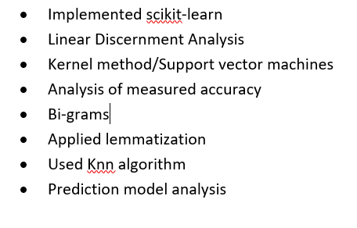

**Approaches /Methods:**

Using Python 3.6, PyCharm (Community edition)

**Workflow &Datasets/Parameters and Evaluation:**



**Question 1:**

**A screenshot of a social media post

Description generated with very high confidence**

**Solution:**

This snippet code provides the above implementation which is linear discriminant analysis and logistic regression. Required packages are downloaded and Iris dataset has been taken in to consideration for predicting the accuracy of each model. The model is trained with the train data and the test data is used to predict the model accuracy. Split ratio of 80%&20% over train and test is taken for building the model.

Below are the differences between the logistic regression and Linear Discriminant Analysis

A picture containing indoor

Description generated with very high confidence

**Data Set : Iris Data set**

**Code Snippet:**

The below is the code for executing the above workflow

A screenshot of a social media post

Description generated with very high confidence

**Output Screenshot:**

**A screenshot of a computer screen

Description generated with very high confidence**

**Question 2:**

**A screenshot of a social media post

Description generated with very high confidence**

**Solution:**

This snippet code provides the above implementation of Support vector classification. Imported the required modules from the python packages. Iris dataset has been loaded to perform SVM. The data is splitted in to 20% testing and 80% training data. Then Applied both the Linear kernel and RBF kernel and reported the below screen shots for the predicted accuracy.

* Linear kernel is best compared to RBF kernel but it also depends on the data set and the data size. It varies mainly when the random state is changed. So it is difficult to figure out which is a better kernel, it mainly depends and varies accordingly to the data.
* **Data Set : Iris Data set**

**Code Snippet:**

The below is the code for executing the above workflow

A screenshot of a social media post

Description generated with very high confidence

**Output Screenshot:**

**Variations in the accuracy depending up on the random state of each kernel.**

**A screenshot of a computer screen

Description generated with very high confidence**

**A screenshot of a computer screen

Description generated with very high confidence**

**Question 3:**

**A screenshot of a cell phone

Description generated with very high confidence**

**Solution:**

This snippet code provides the above implementation of lemmatization, bigram, top rated 5-word s and the concatenation of the sentences. Input file is loaded and below code is used for performing the above steps.

**Data Set : A sample text file with the paragraph**

**Code Snippet:**

The below is the code for executing the above workflow

A screenshot of a social media post

Description generated with very high confidence

**Output Screenshot:**

**A screenshot of a computer screen

Description generated with very high confidence**

**Question 4:**

**A picture containing object

Description generated with high confidence**

**Solution:**

This snippet code provides the above implementation KNN algorithm with different k values. When the k value increases, the model will better fit into the training data and get the accurate results while compared to the less k value. The K value has more effect on the test data So there will be variation in predicting the accuracy.

**Data Set : Iris Data set**

**Code Snippet:**

The below is the code for executing the above workflow

A screenshot of a social media post

Description generated with very high confidence

**Output Screenshot:**

**A screenshot of a computer screen

Description generated with very high confidence**

**A screenshot of a computer screen

Description generated with very high confidence**

**Conclusion:**

As stated the above workflow with certain set of parameters is followed in solving the execution by implementing the core and basic concepts of the python programming.

**Source code link** <https://github.com/PragathiThammaneni/Python-and-deep-Learning/tree/master/Lab%202/Source%20code>

**Video Link:** <https://youtu.be/OdlXO6z8gCE> (made a short video as it should be less time)

**Wiki Link:**

<https://github.com/PragathiThammaneni/Python-and-deep-Learning/wiki/Lab-2-Assignment>